CREATE DATABASE BankDB;

USE BankDB;

============================================================
2. CREATE CUSTOMER TABLE
============================================================

CREATE TABLE Customer (
Customer_ID INT PRIMARY KEY,
Customer_Name VARCHAR(100) NOT NULL,
Phone VARCHAR(15),
Email VARCHAR(100),
City VARCHAR(50)
);

============================================================
3. CREATE ACCOUNT TABLE
============================================================

CREATE TABLE Account (
Account_No INT PRIMARY KEY,
Customer_ID INT,
Account_Type VARCHAR(20),
Balance DECIMAL(12,2),
Branch VARCHAR(50),

FOREIGN KEY (Customer_ID)
REFERENCES Customer(Customer_ID)
);

============================================================
4. CREATE BANK TRANSACTION TABLE
============================================================

CREATE TABLE Bank_Transaction (
Transaction_ID INT PRIMARY KEY AUTO_INCREMENT,
Account_No INT,
Transaction_Type VARCHAR(20),
Amount DECIMAL(12,2),
Transaction_Date DATETIME DEFAULT CURRENT_TIMESTAMP,

FOREIGN KEY (Account_No)
REFERENCES Account(Account_No)
);

============================================================
5. CREATE LOAN TABLE
============================================================

CREATE TABLE Loan (
Loan_ID INT PRIMARY KEY,
Customer_ID INT,
Loan_Type VARCHAR(30),
Loan_Amount DECIMAL(12,2),
Interest_Rate DECIMAL(5,2),

FOREIGN KEY (Customer_ID)
REFERENCES Customer(Customer_ID)
);

============================================================
6. INSERT CUSTOMER DATA
============================================================

INSERT INTO Customer
(Customer_ID, Customer_Name, Phone, Email, City)
VALUES
(101, 'Ravi Kumar', '9876543210',
'ravi@gmail.com', 'Hyderabad'),

(102, 'Priya Sharma', '9876543211',
'priya@gmail.com', 'Vijayawada'),

(103, 'Arjun Reddy', '9876543212',
'arjun@gmail.com', 'Bangalore'),

(104, 'Sneha Rao', '9876543213',
'sneha@gmail.com', 'Chennai'),

(105, 'Kiran Kumar', '9876543214',
'kiran@gmail.com', 'Hyderabad'),

(106, 'Anil Kumar', '9876543215',
'anil@gmail.com', 'Delhi'),

(107, 'Meena Reddy', '9876543216',
'meena@gmail.com', 'Mumbai'),

(108, 'Rahul Sharma', '9876543217',
'rahul@gmail.com', 'Pune'),

(109, 'Lakshmi Devi', '9876543218',
'lakshmi@gmail.com', 'Hyderabad'),

(110, 'Suresh Babu', '9876543219',
'suresh@gmail.com', 'Vijayawada');
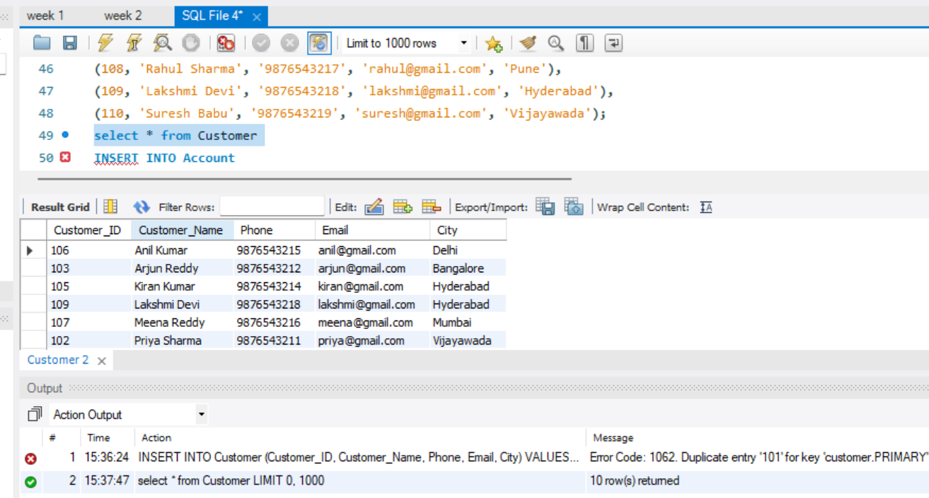

============================================================
7. INSERT ACCOUNT DATA
============================================================

INSERT INTO Account
(Account_No, Customer_ID, Account_Type, Balance, Branch)
VALUES
(10001, 101, 'Savings', 50000, 'Hyderabad'),

(10002, 102, 'Savings', 75000, 'Vijayawada'),

(10003, 103, 'Current', 120000, 'Bangalore'),

(10004, 104, 'Savings', 45000, 'Chennai'),

(10005, 105, 'Current', 90000, 'Hyderabad'),

(10006, 106, 'Savings', 65000, 'Delhi'),

(10007, 107, 'Current', 150000, 'Mumbai'),

(10008, 108, 'Savings', 35000, 'Pune'),

(10009, 109, 'Savings', 85000, 'Hyderabad'),

(10010, 110, 'Current', 110000, 'Vijayawada');
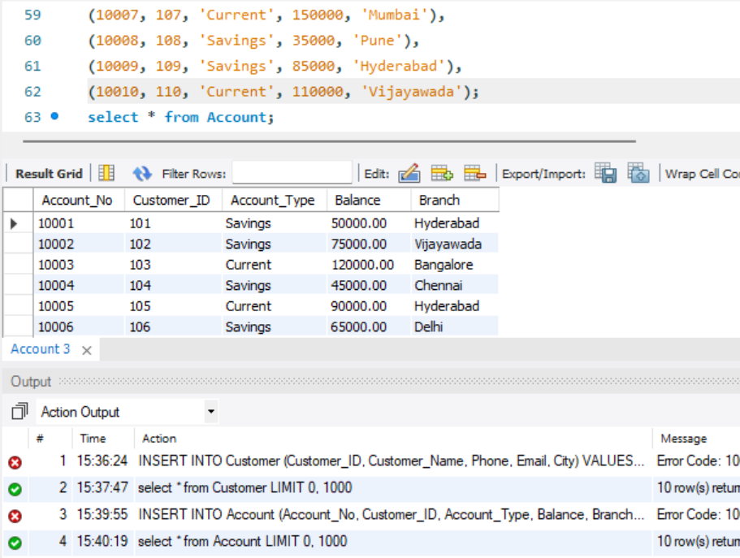

============================================================
8. INSERT TRANSACTION DATA
============================================================

INSERT INTO Bank_Transaction
(Account_No, Transaction_Type, Amount)
VALUES
(10001, 'DEPOSIT', 10000),

(10001, 'WITHDRAW', 5000),

(10002, 'DEPOSIT', 15000),

(10003, 'WITHDRAW', 20000),

(10004, 'DEPOSIT', 5000),

(10005, 'WITHDRAW', 10000),

(10006, 'DEPOSIT', 12000),

(10007, 'DEPOSIT', 25000),

(10008, 'WITHDRAW', 5000),

(10009, 'DEPOSIT', 20000),

(10010, 'WITHDRAW', 15000);
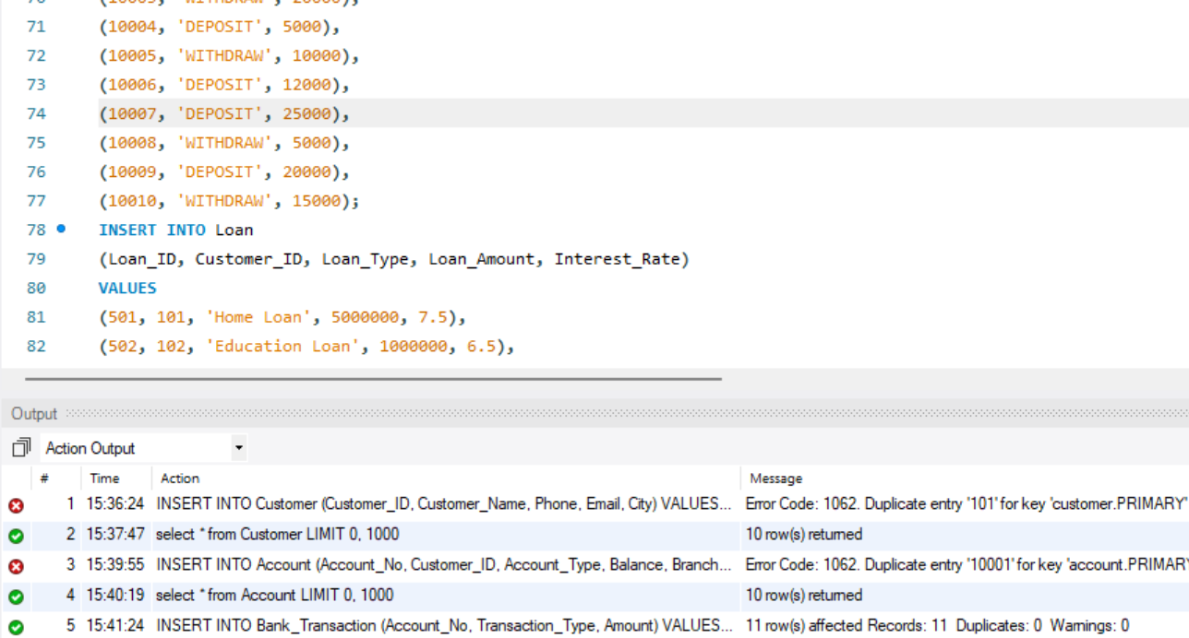

============================================================
9. INSERT LOAN DATA
============================================================

INSERT INTO Loan
(Loan_ID, Customer_ID, Loan_Type,
Loan_Amount, Interest_Rate)
VALUES
(501, 101, 'Home Loan', 5000000, 7.5),

(502, 102, 'Education Loan', 1000000, 6.5),

(503, 103, 'Car Loan', 800000, 8.2),

(504, 104, 'Personal Loan', 500000, 10.5),

(505, 105, 'Home Loan', 4000000, 7.2),

(506, 106, 'Car Loan', 900000, 8.5),

(507, 107, 'Business Loan', 3000000, 9.0),

(508, 109, 'Personal Loan', 600000, 10.0);
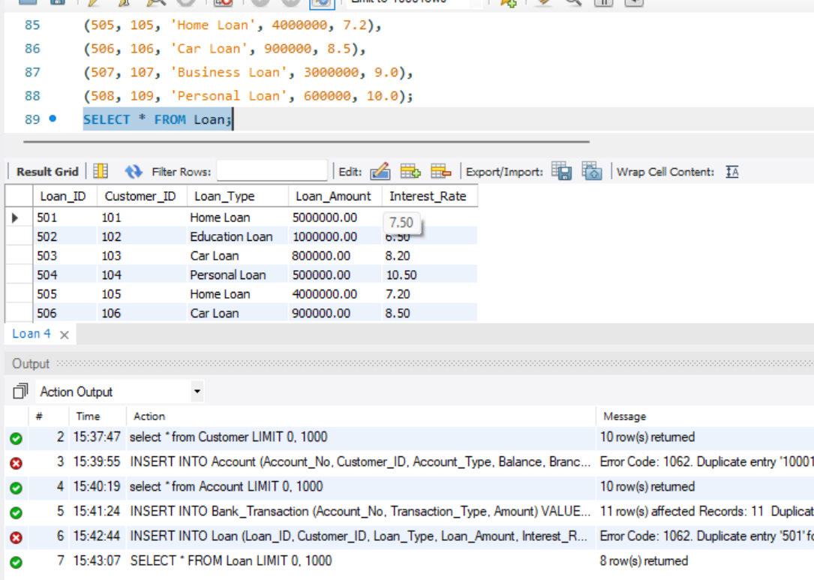

============================================================
10. DISPLAY ORIGINAL TABLES
============================================================

SELECT * FROM Customer;
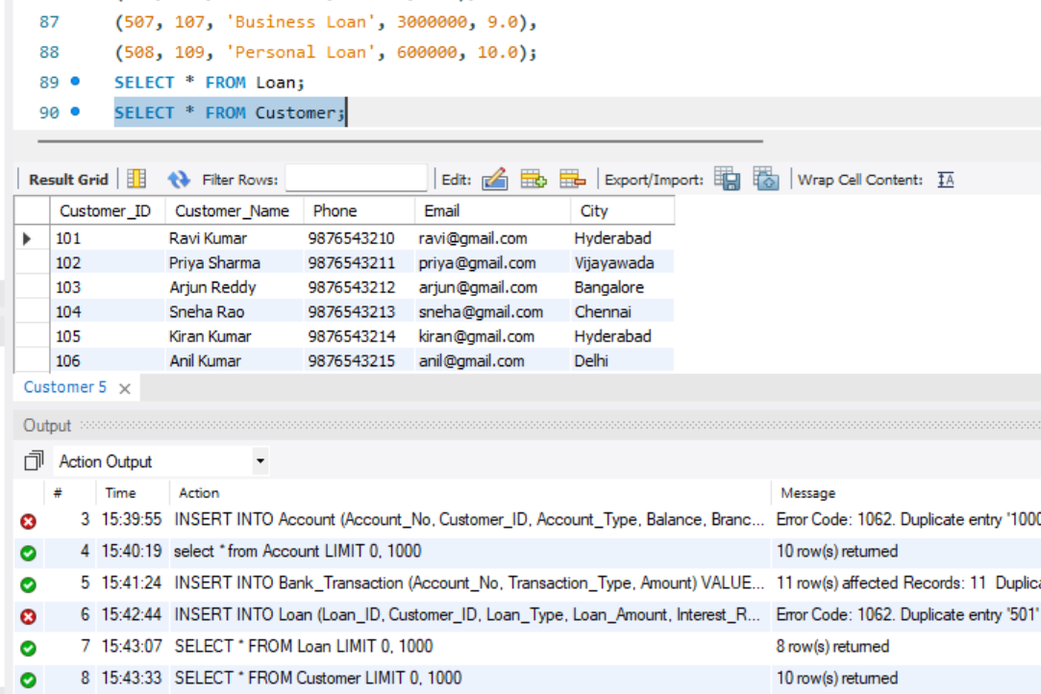

SELECT * FROM Account;
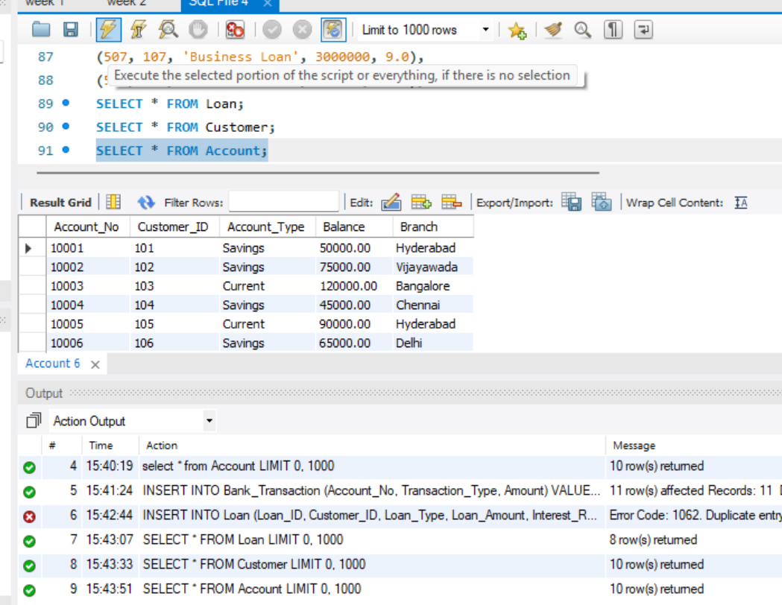

SELECT * FROM Bank_Transaction;
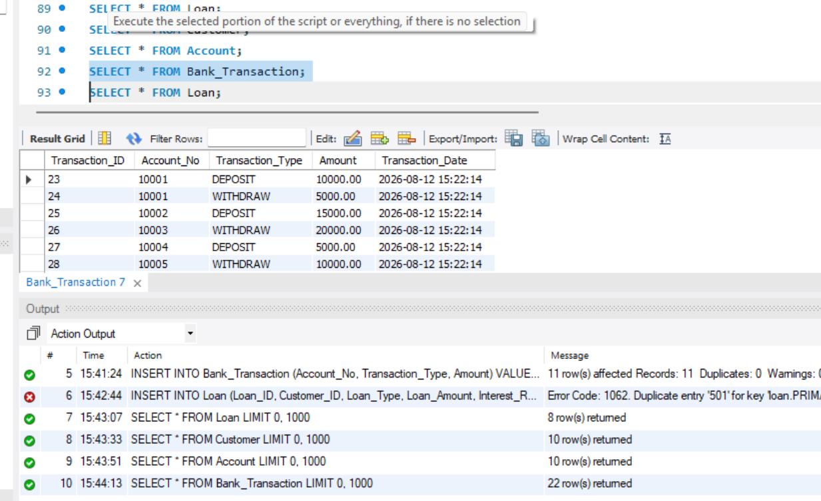

SELECT * FROM Loan;
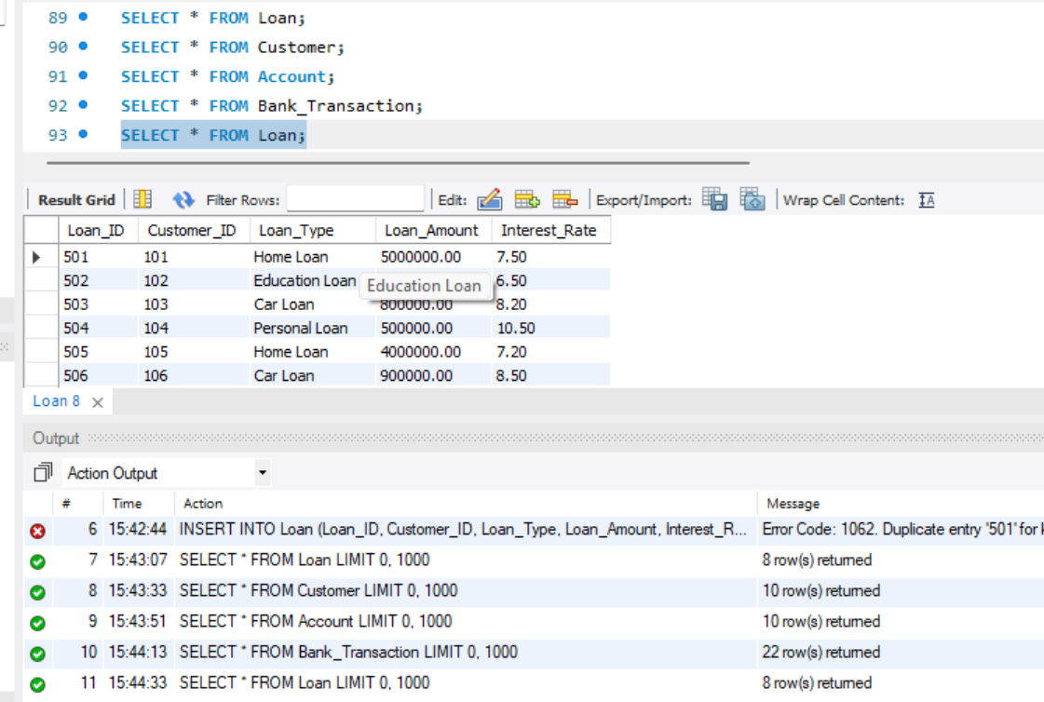

============================================================
PART A – SIMPLE VIEWS
============================================================

------------------------------------------------------------
11. CREATE A VIEW FOR ALL CUSTOMERS
------------------------------------------------------------

CREATE VIEW Customer_View AS
SELECT *
FROM Customer;

DISPLAY VIEW:

SELECT * FROM Customer_View;
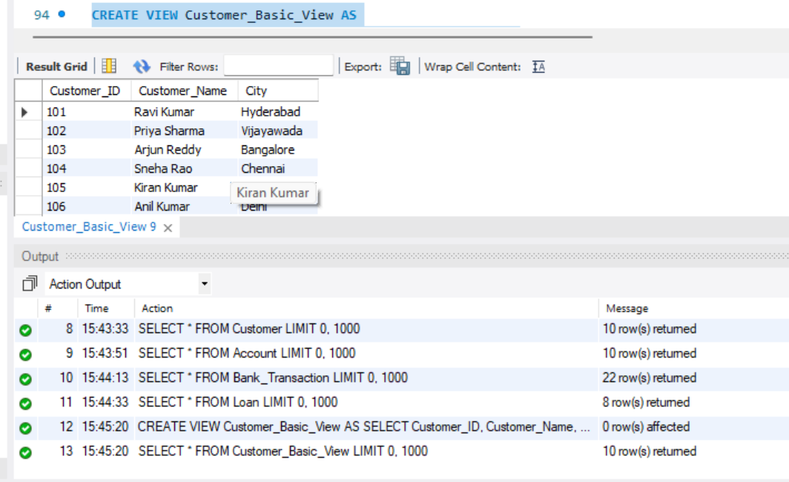

------------------------------------------------------------
12. CREATE A VIEW FOR CUSTOMER BASIC INFORMATION
------------------------------------------------------------

CREATE VIEW Customer_Basic_View AS
SELECT
Customer_ID,
Customer_Name,
City
FROM Customer;

DISPLAY:

SELECT * FROM Customer_Basic_View;
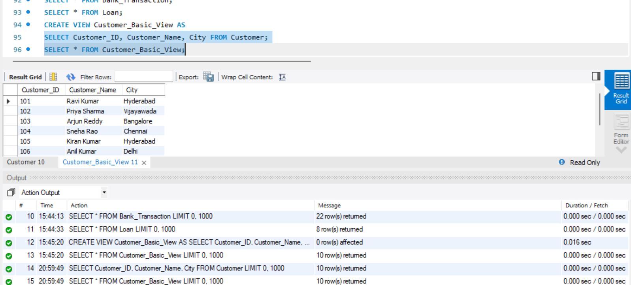

------------------------------------------------------------
13. CREATE A VIEW FOR ACCOUNT INFORMATION
------------------------------------------------------------

CREATE VIEW Account_View AS
SELECT
Account_No,
Account_Type,
Balance,
Branch
FROM Account;

DISPLAY:

SELECT * FROM Account_View;
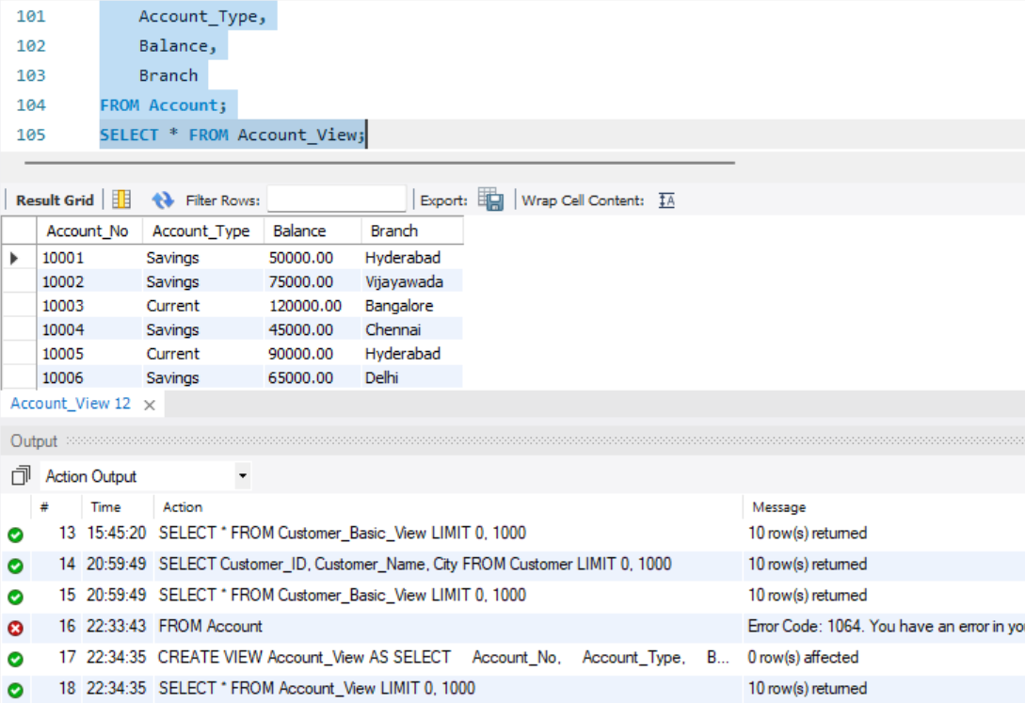

------------------------------------------------------------
14. CREATE A VIEW FOR SAVINGS ACCOUNTS
------------------------------------------------------------

CREATE VIEW Savings_Account_View AS
SELECT *
FROM Account
WHERE Account_Type = 'Savings';

DISPLAY:

SELECT * FROM Savings_Account_View;

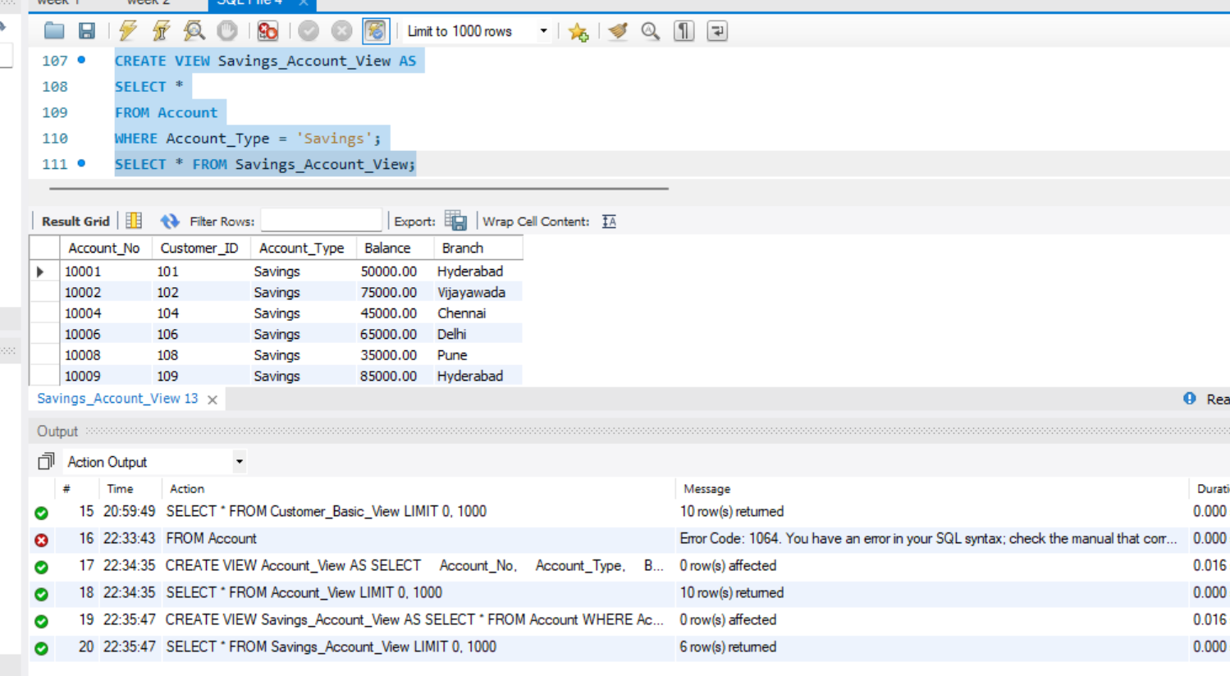
------------------------------------------------------------
15. CREATE A VIEW FOR CURRENT ACCOUNTS
------------------------------------------------------------

CREATE VIEW Current_Account_View AS
SELECT *
FROM Account
WHERE Account_Type = 'Current';

DISPLAY:

SELECT * FROM Current_Account_View;
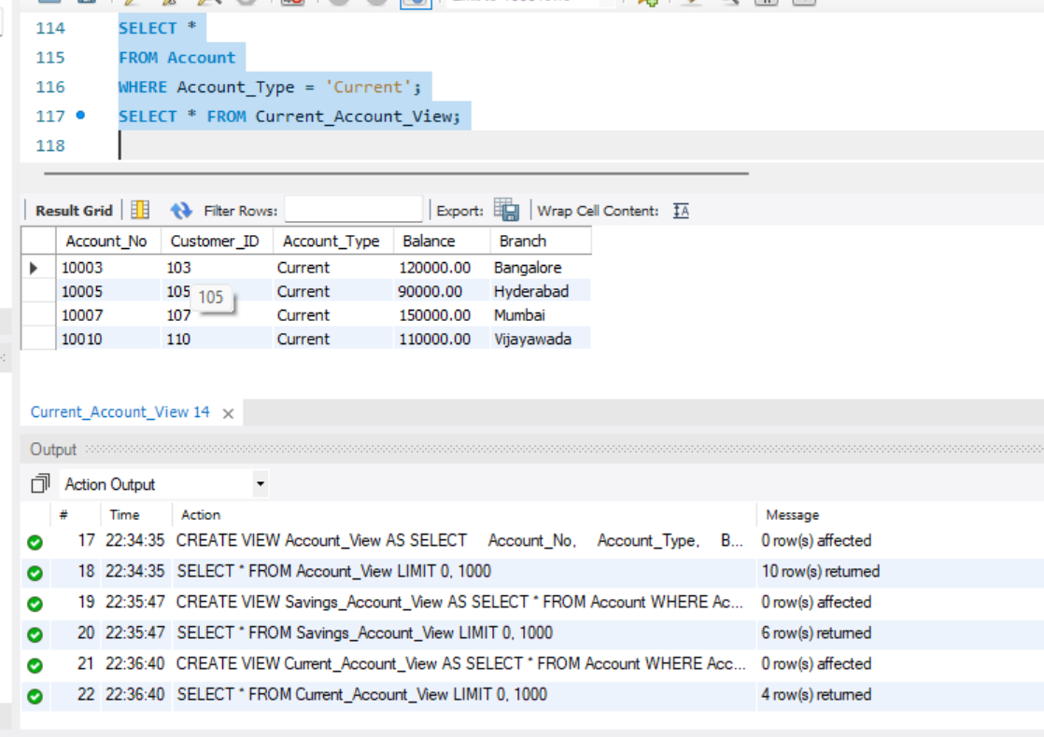

============================================================
PART B – VIEWS WITH CONDITIONS
============================================================

------------------------------------------------------------
16. HIGH BALANCE ACCOUNT VIEW
------------------------------------------------------------

CREATE VIEW High_Balance_View AS
SELECT
Account_No,
Customer_ID,
Account_Type,
Balance
FROM Account
WHERE Balance > 100000;

DISPLAY:

SELECT * FROM High_Balance_View;
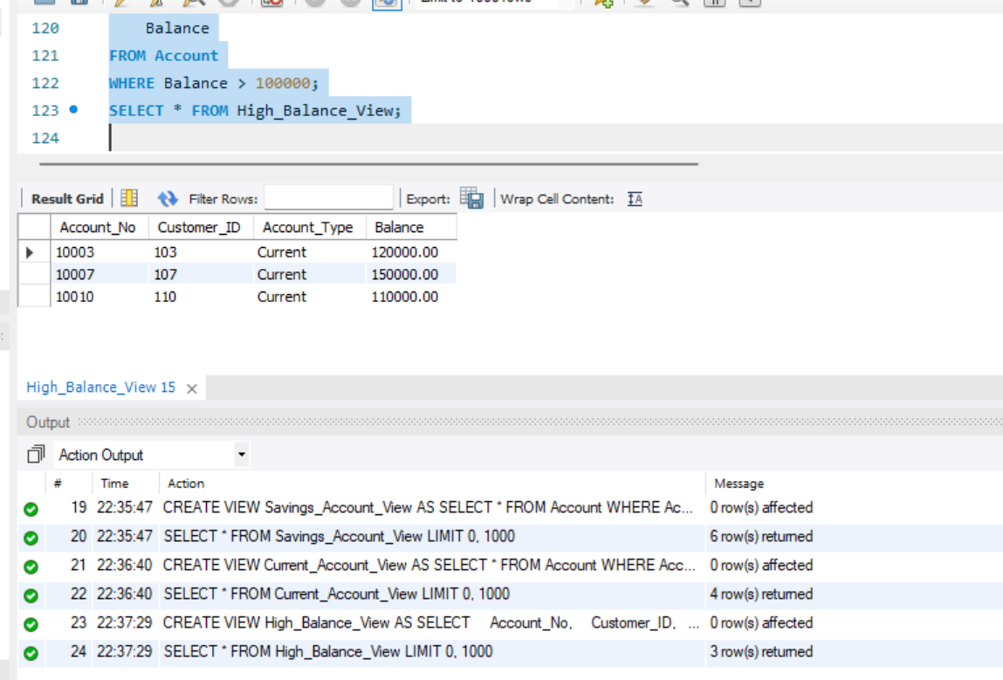

------------------------------------------------------------
17. HYDERABAD ACCOUNT VIEW
------------------------------------------------------------

CREATE VIEW Hyderabad_Account_View AS
SELECT *
FROM Account
WHERE Branch = 'Hyderabad';

DISPLAY:

SELECT * FROM Hyderabad_Account_View;

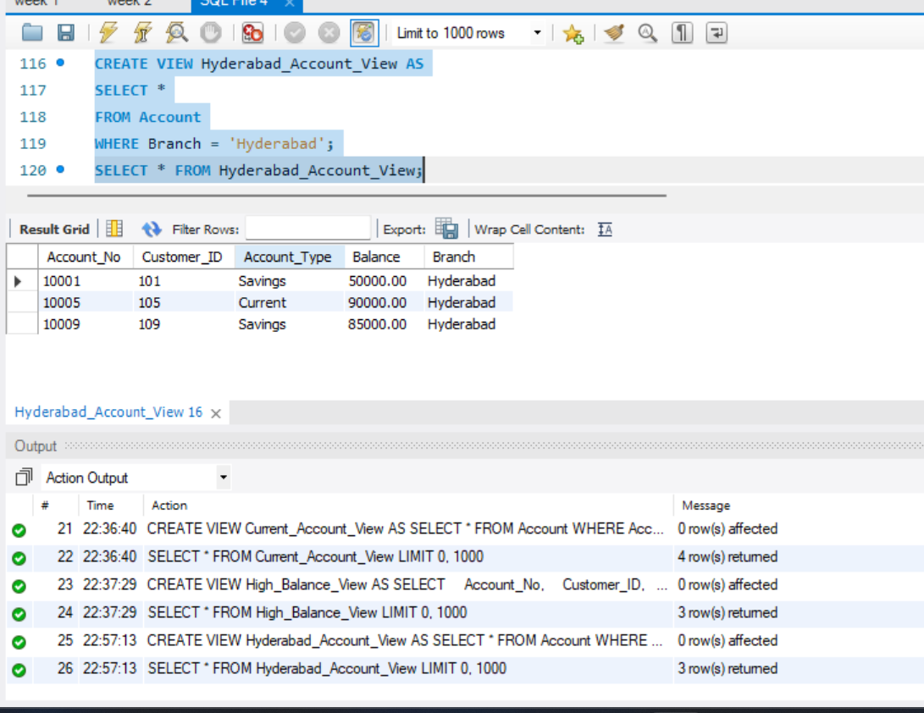
------------------------------------------------------------
18. LOW BALANCE ACCOUNT VIEW
------------------------------------------------------------

CREATE VIEW Low_Balance_View AS
SELECT
Account_No,
Customer_ID,
Balance
FROM Account
WHERE Balance < 50000;

DISPLAY:

SELECT * FROM Low_Balance_View;
CREATE VIEW Low_Balance_View AS
SELECT
Account_No,
Customer_ID,
Balance
FROM Account
WHERE Balance < 50000;

DISPLAY:

SELECT * FROM Low_Balance_View;

============================================================
PART C – VIEWS USING JOINS
============================================================

------------------------------------------------------------
19. CUSTOMER + ACCOUNT VIEW
------------------------------------------------------------

CREATE VIEW Customer_Account_View AS
SELECT
C.Customer_ID,
C.Customer_Name,
C.City,
A.Account_No,
A.Account_Type,
A.Balance,
A.Branch
FROM Customer C
JOIN Account A
ON C.Customer_ID = A.Customer_ID;

DISPLAY:

SELECT * FROM Customer_Account_View;

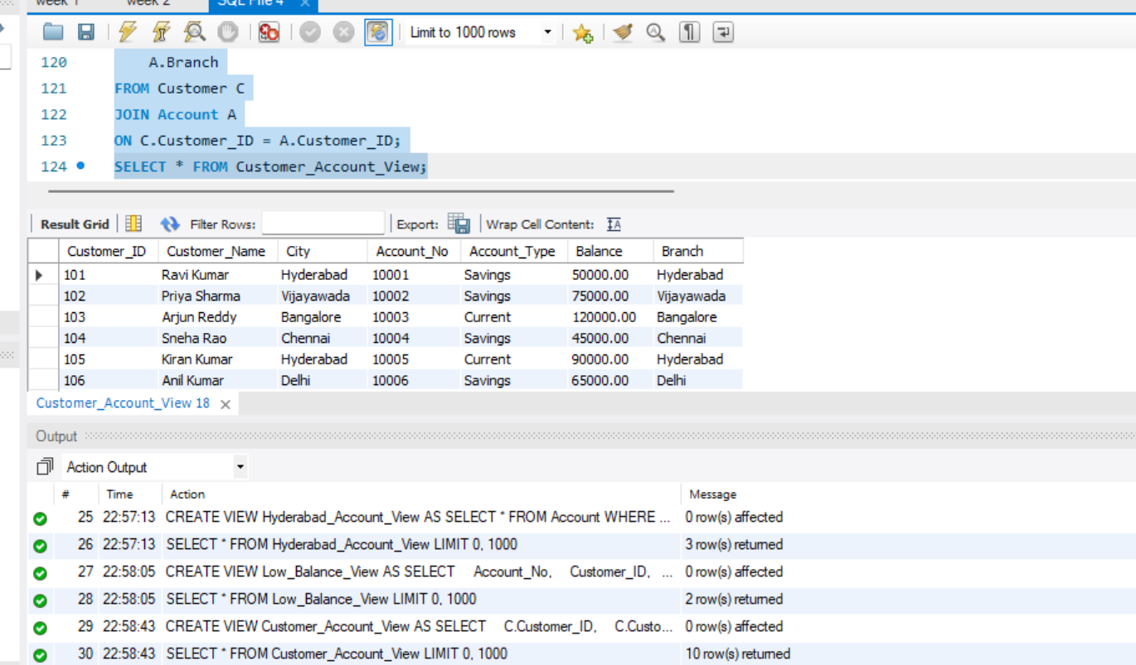
------------------------------------------------------------
20. HYDERABAD CUSTOMER ACCOUNT VIEW
------------------------------------------------------------

CREATE VIEW Hyderabad_Customer_Accounts AS
SELECT
C.Customer_Name,
C.City,
A.Account_No,
A.Account_Type,
A.Balance
FROM Customer C
JOIN Account A
ON C.Customer_ID = A.Customer_ID
WHERE A.Branch = 'Hyderabad';

DISPLAY:

SELECT * FROM Hyderabad_Customer_Accounts;
